**PL/SQL**

1. PL/SQL stands for “Procedural Language extensions to the Structured Query Language”.
2. [SQL](https://www.oracletutorial.com/oracle-basics/) is a popular language for both [querying](https://www.oracletutorial.com/oracle-basics/oracle-select/) and [updating data](https://www.oracletutorial.com/oracle-basics/oracle-update/) in the relational database management systems (RDBMS).
3. PL/SQL adds many procedural constructs to SQL language to overcome some limitations of SQL.
4. PL/SQL provides a more comprehensive programming language solution for building mission-critical applications on Oracle Databases.
5. PL/SQL is a standard and portable language for Oracle Database development.
6. If you develop a program that executes on an Oracle Database.
7. You can quickly move it to another compatible Oracle Database without any changes.

## PL/SQL architecture:

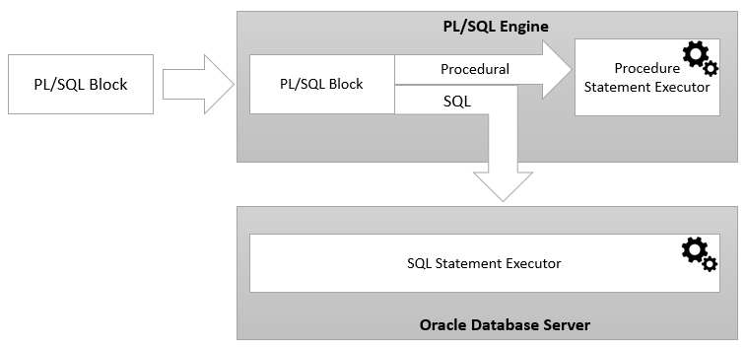

## PL/SQL package :

PL/SQL, a package is a schema object that contains definitions for a group of related functionalities.

A package includes [variables](https://www.oracletutorial.com/plsql-tutorial/plsql-variables/), [constants](https://www.oracletutorial.com/plsql-tutorial/plsql-constants/), [cursors](https://www.oracletutorial.com/plsql-tutorial/plsql-cursor/), [exceptions](https://www.oracletutorial.com/plsql-tutorial/plsql-exception/), [procedures](https://www.oracletutorial.com/plsql-tutorial/plsql-procedure/), [functions](https://www.oracletutorial.com/plsql-tutorial/plsql-function/), and subprograms. It is compiled and stored in the Oracle Database.

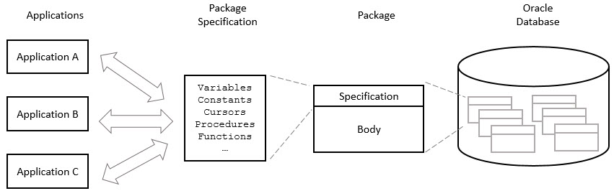**Picture illustrates PL/SQL packages:**

## PL/SQL block:

A PL/SQL block has a name. [Functions](https://www.oracletutorial.com/plsql-tutorial/plsql-function/) or [Procedures](https://www.oracletutorial.com/plsql-tutorial/plsql-procedure/) is an example of a named block.

A named block is stored into the Oracle Database server and can be reused later.

A block without a name is an anonymous block.

An anonymous block is not saved in the Oracle Database server, so it is just for one-time use.

However, PL/SQL anonymous blocks can be useful for testing purposes.

Structure of a PL/SQL block:

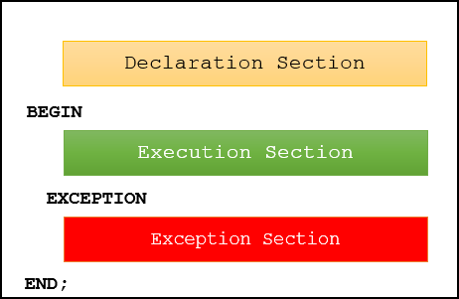

1) Declaration section

A PL/SQL block has a declaration section where you declare variables, allocate memory for cursors, and define data types.

2) Executable section

A PL/SQL block has an executable section. An executable section starts with the keyword BEGIN and ends with the keyword END. The executable section must have a least one executable statement, even if it is the NULL statement which does nothing.

3) Exception-handling section

A PL/SQL block has an exception-handling section that starts with the keyword EXCEPTION. The exception-handling section is where you catch and handle exceptions raised by the code in the execution section.

## PL/SQL anonymous block example:

PL/SQL anonymous block with one executable section.

|  |
| --- |
| BEGIN  DBMS_OUTPUT.put_line ('Hello World!');  END; |

## Execute a PL/SQL anonymous block:

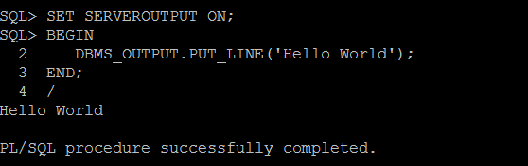

First, connect to the Oracle Database server using a username and password.

Second, turn on the server output using the SET SERVEROUTPUT ON command so that the DBMS_OUTPUT.PUT_LINE procedure will display text on the screen.

Third, type the code of the block and enter a forward slash ( /) to instruct SQL*Plus to execute the block.

Once you type the forward-slash (/), SQL*Plus will execute the block and display the Hello World